1. Log in to SRV2 with an administrator user account.
2. If Server Manager does not open, open Server Manager..
3. In Server Manager, click Manage > Add Roles and Features. The Add Roles and Feature Wizard opens.
4. On the Before you begin page, click Next.
5. Select Role‐based or feature‐based installation and then click Next.
6. On the Select destination server page, click Next.
7. On the Select server roles page, click Next.
8. On the Select features page, select BitLocker Drive Encryption.
9. In the Add Roles and Features Wizard dialog box, click Add Features.
10. On the Select Features page, click Next.
11. On the Confirm installation selections page, click Install.
12. When BitLocker is installed, click Close.
13. Restart SRV2.
14. Click the Start button and then click the Control Panel tile.
15. Click System and Security > BitLocker Drive Encryption. The BitLocker Drive Encryption window opens.
16. Click the down arrow next to the C drive. Then click Turn on BitLocker.
17. The following error will pop up.

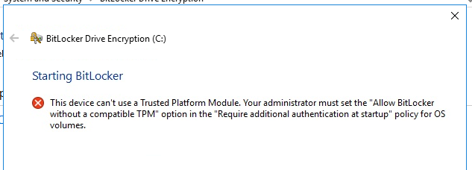

1. Click cancel and use internet resources to figure out how to proceed.
2. Once you set the appropriate settings attempt to encrypt the drive again.
3. On the Choose how you want to unlock this drive page, click to select the Use a password to unlock the drive. Type a password of Password#1 in the Enter your password text box and the Reenter your password text box. Click Next.
4. On the How do you want to back up your recovery key? page, click Save to a file.
5. In the Save BitLocker recovery key as dialog box, type \\SRV1\C$\ BitLocker Recovery Key <GUID>.txt and then click Save. Click Next.

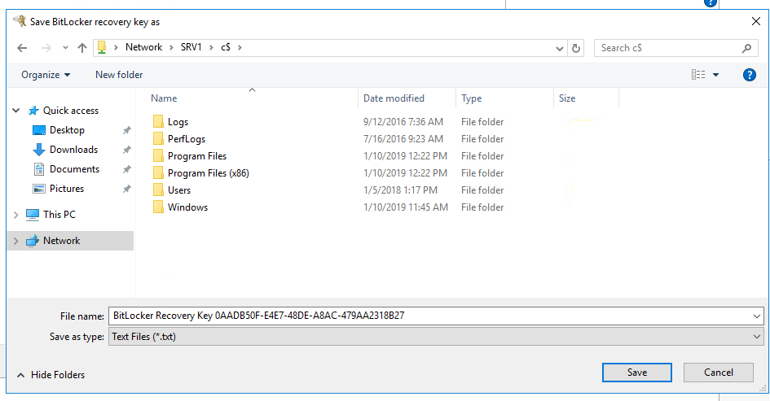

1. On the Choose which encryption mode to use page, read the two available options and then click Next.
2. On the Are you ready to encrypt this drive? page, click Start encrypting.
3. Restart the server.
4. Screenshot the enter the password screen for submission to canvas
5. Enter the password for BitLocker to proceed.